This file has been downloaded from Inland Norway University of Applied Sciences’ Open Research Archive, http://brage.bibsys.no/inn/

The article has been peer-reviewed, but does not include the publisher’s layout, page numbers and proof-corrections

Citation for the published paper:
[Özkan, O., Obekpa, H. O., & Alola, A. A. (2023). Examining the nexus of energy intensity, renewables, natural resources, and carbon intensity in India. Energy & Environment, 0(0).DOI: https://doi.org/10.1177/0958305X231169706]

Examining the nexus of energy intensity, renewables, natural resources, and carbon intensity in India
Abstract
India remained the third-largest energy consumer in the world, responsible for around 7% of global carbon emissions due to rising incomes and improving living standards. Although resource extraction has quadrupled since 1970 due to rising population and demand for natural resources, energy use and transformation, notably of fossil fuel energy, have increased by around 45%, thus increasing greenhouse gas (GHG) emissions. In this view, this study aims to explore energy intensity, renewable energy, natural resources, economic growth, and environmental degradation nexus in India. The novel dynamic simulated autoregressive distributed lag and kernel-based regularized least squares (KRSL) approaches are used to explore the effects of energy intensity, renewable energy, natural resources, and economic growth on carbon intensity for India from 1970 to 2020. The empirical results reveal that renewable energy and natural resources improve India’s environmental quality via the mitigation of carbon emissions. It is aso found that energy intensity and economic growth deteriorate the country’s environmental quality by increasing carbon emissions in the short- and long run. A series of robustness estimation affirms the above evidence, thus providing requisite guideline for relevant policy recommendations for the country.
Keywords: India, carbon intensity, renewable energy, energy intensity, natural resources, dynamic simulated ARDL, KRLS.

Abbreviations
ADF: Augmented Dickey-Fuller
AIC: Akaike information criterion
ARDL: Autoregressive distributive lag
CINT: Carbon intensity
CO₂: Carbon dioxide
CUSUM: Cummulative sum
DSARDL: Dynamic simulated autoregressive distributive lag
EG: Economic growth
EINT: Energy intensity
ECT: Error correction term
FPE: Final prediction error
GHG: Greenhouse gas
GIZ: German agency for international cooperation
GDP: Gross Domestic Product
HQ: Hannan-Quinn information criterion
IEA: International Energy Agency
kWh: Kilowatt per hour
KRLS: Kernel-Based regularized least squares
KS: Kripfganz-Schneider
LR: Sequential modified LR test statistic
Mtoe: Million tonnes of oil equivalent
NRR: Natural resource rent
REC: Renewable energy consumption
OECD: Organisation for Economic Co-operation and Development
PP: Phillips-Perron
PSS: Pesaran, Shin, and Smith
SC: Schwarz information criterion
OWD: Our wold in data
WDI: World development indicator
Δ: Short run

1. Introduction
The concepts of energy intensity, renewable energy, natural resources and carbon intensity are central to environmental sustainability. Energy intensity is an indirect approach of measuring energy efficiency, suggesting that energy intensity is more concerned with energy leanness (quantity) than energy cleanliness (Eurostat, 2016). Energy intensity tends to increase as populations increase due to the expected increase in the demand for energy product. According to the Organisation for Economic Co-operation and Development (OECD), energy intensity has been examined and recognized as a significant factor in determining the direction of the energy transition towards establishing a low-carbon economy (OECD, 2011). For example, India's total primary energy consumption was 659 million tonnes of oil equivalent (Mtoe) in 2015; it is projected to increase to 1,440 Mtoe by 2030. Therefore, affirming that energy efficiency remains a crucial option for advancing the development agenda and combating the effects of environmental degradation and climate change.
Renewable energy is a substitute for non-renewable energy sources, thus making renewable energy sources desirable for sustainable environment and being deliberately utilized to drive energy transition and mitigating environmental deterioration across the globe (Alola et al., 2019 & 2022; Shah et al., 2022). It is noteworthy that as the demand for natural resources and the world's population grows, energy utilization and transformation, particularly of fossil fuel energy, have increased by about 45% even as resource extraction has tripled since 1970, leading to an increase in greenhouse gas (GHG) emissions (United Nations, 2021). Thus, natural resource rent (NRR) plays a vital role in determining the degree of carbon emissions and environmental sustainability. This is because natural resource-rich economies should ordinarily fare better and expand more quickly economically than those with limited natural capital and resources (Huang et al., 2020; Ncube & Koloba, 2020; Umar et al., 2020). However, one of the main limitations of the available literature is that there is almost lack of agreement on whether the NRR has a significant positive or negative impact on environmental sustainability (Huang et al., 2021). Furthermore, the degradation of natural resources and pollution issues are global issues, as a result, the problems are intertwined and cannot be resolved separately (Menegaki & Tsani, 2018).
The performance of a region's carbon emissions can be evaluated using carbon emissions per unit of GDP, commonly known as carbon intensity. Going by this, India is now the third-largest energy consumer in the world, responsible for around 7% of global carbon emissions due to rising incomes and improving living standards. Although it is still far behind China, the world's greatest emitter, and the United States, India is currently the third-highest producer of carbon dioxide on the planet. Widespread wealth disparity (income inequality), unequal development, and other problems persists in India (Parikh & Parikh, 2016). Additionally, International Energy Agency (IEA) noted that 244 million individuals in India's population of over 1.2 billion people lack access to power (IEA, 2016). As a result, the government placed a higher priority on tackling the problem of poverty than on finding solutions to environmental issues. Therefore, a measure of carbon intensity which is associated with economic growth rather than just focusing on overall carbon dioxide (CO₂) emissions will allow a more accurate evaluation of India's emissions reduction efforts (Sun et al., 2017). According to Wang et al. (2020), the necessity for emerging countries to reduce their carbon intensity is currently being debated internationally due to the increasing industrialization and urbanization that is being fueled by excessive energy use (Kang et al., 2016; Cheng et al., 2018; Hanif et al., 2019). Since 2000, energy consumption has increased, with coal, oil, and solid biomass still meeting 80% of the need. As a result, one-third of the world's greenhouse gas emissions have come from coal, oil, and natural gas. Furthermore, with an annual urban population increase of the equivalent of a city the size of Los Angeles, India will soon surpass China as the world's most populated nation (IEA, 2021). As the population increases, it is expected that the country will make leaps in its development which will come at the cost of increased energy consumption.
Numerous studies have associated CO₂ emissions and carbon intensity with environmental sustainability (Douglas & Nishioka, 2012; Majumdar & Kar, 2017; Hongdou et al., 2018; Zhu et al., 2018; Bekun et al., 2019; Danish et al., 2019). Additionally, exploring carbon intensity alongside energy intensity, renewable energy, and natural resources is not well-reported in the literature especially for India’s perspective. It is also essential to study India in light of recent events in climate change, population and developmental projections. While facing severe threats from the changing climate, including rising sea levels, vanishing glaciers, and extreme weather events, India is also committed to a robust energy transiton plan that offers net zero emissions by 2070 and achieving 50% share of renewable electricity by 2030 (The Washington Post, 2020; IEA, 2022). By using the robust dynamic stimulated autoregressive distributed lag (DSARDL) and Kernel-Based regularized least squares (KLS), this paper makes a novel contribution to the literature by examining the effect of energy intensity, renewable energy, natural resources and economic growth on the carbon intensity of India. Given India's growing relevance in achieving the Sustainable Development Goals by 2030 and the potential environmental consequences it is anticipated to experience. The next section (2) explains the model, variable description and the methodology employed. Section 3 contains the empirical result, while the conclusion and policy insight are explained in the last section (4).
2. Literature review: Indian perspective
The role of economic growth in environmental quality has been widely investigated in the literature for different cases. Specifically for the case of India, Udemba (2022) implemented the autoregressive distributed lag (ARDL) to examined the environmental effect of economic growth (GDP), foreign direct investment (FDI), fossil fuels, and institutional quality over the period 1996Q1-2018Q4. The result from the investigation shows that institutional quality improves environmental quality by mitigating carbon emissions in the short- and long run. Additionally, GDP, FDI and fossil fuels are detrimental to environmental quality because they both causes surge in carbon emission in the country in short- and long-run. This study and its outcomes are also similar to the asymmetric evidence in Akadiri and Adebayo (2022). Specifically, with the implementation of non-linear ARDL for dataset that covers the period, the result reveals that a positive shock on GDP worsen environmental quality by increasing carbon emissions in India. In addition to the above studies, the environmental effect of economic growth and economic freedom has also been documented for India through its membership of the BRICS (Brazi, Russia, India, China, and South Africa) countries (Akadırı et al., 2021; Zoaka et al., 2022).
The role of energy resources and by large natural resources in environmental quality in India have been covered in the literature (Damerau et al., 2020; Itoo & Ali, 2023). For instance, Itoo and Ali (2023) employed the dataset that covers the period 1980–2018 to provide insight on the environmental effect of natural resources and energy aspects in india. By implementing ARDL approach alongside the robustness techniques of FMOLS, DOLS, and CCR (respectively fully modified ordinary least squares, dynamic ordinary least squares, and canonical cointegrating regression), the study reveals that the depletion of natural resource alongside remittances inflow and industrial output shows a negatively long run but insignificant impact on carbon emissions in India. Also in the long run, GDP, population, and energy consumption negatively affect environmental quality by promoting carbon emission in the country and without validating the environmental Kuznets curve (EKC) hypothesis. In line with natural resources (land, fresh water) and GHG emission nexus, subnational environmental insight was investigated in Damerau et al. (2020). Specifically, the results show that regional usage of cropland and water resources could be up to 50% and 65% respectively, thus accounting for total natural resources depletion of about 40%. This resource utilisation is expected to help India acheive the national food self-sufficiency goals while also achieving GHG emissions reduction of about 26–34% especially through agroforestry emission sequestration.
Given the evidence from the literature on the drivers of environmental degradation in India, the current study extends the literature by implementing carbon intensity as environmental quality indicator while also considering energy intensity, renewable energy, and natural resources which are clearly missing approaches in previous studies. However, in related to other economies across the globe, studies have also captured large array of countries in similar perspectives (Wang et al., 2023a, 2023b).
2. Model, variables description, and methodology
This study empirically analyzes energy intensity, renewable energy, natural resources, economic growth, and carbon intensity nexus in India by using the empirical model outlined in equation (1). This investigated model follows the STIRPAT (Stochastic Impacts by Regression on Population, Affluence and Technology) underlying framework in the earlier works (Holdren & Ehrlich, 1974; York et al., 2003).
$${ƖƞCINT}_{t}=Ɣ_{0}+Ɣ_{1}{ƖƞEINT}_{t}+Ɣ_{2}{ƖƞREC}_{t}+Ɣ_{3}{ƖƞNR}_{t}+Ɣ_{4}{ƖƞEG}_{t}+Ɛ_{t}$$ | (1)
where $t$ illustrates time, $Ɩƞ$ represents the logarithm, $Ɣ_{0}$ indicates the constant term, $Ɣ_{1}$ and $Ɣ_{2}$ demonstrate the coefficients of the predictor variables, $Ɣ_{3}$ and $Ɣ_{4}$ show the coefficients of the control variables, and $Ɛ_{t}$ signifies the error term. Moreover, $CINT$, $EINT$, $REC$, $NR$, and $EG$ symbolize carbon intensity, energy intensity, renewable energy consumption, natural resources, and economic growth, respectively.
2.1. Variables description
For empirical analysis, the paper uses the available annual time-series data ranging from 1970 to 2020. The predicted variable of this paper is carbon intensity, i.e., environmental degradation. In contrast to carbon dioxide emissions and ecological footprint, carbon intensity comprises both the environmental and economic consequences of human activities, which makes it an appropriate indicator of environmental degradation (Ahmad & Wu, 2022). Therefore, the study employs carbon intensity as a proxy for environmental degradation rather than CO₂ emissions or ecological footprint.
Additionally, the factor variables of this paper are energy intensity, renewable energy, natural resources, and economic growth. Following Goldemberg (2020) and Ahmad & Wu (2022) studies, carbon intensity is measured as per capita CO₂ emissions per unit of GDP per capita and energy intensity is measured as per capita energy consumption per unit of GDP per capita, respectively. Following Khan et al. (2021), total natural resources rents as a percentage of GDP are used as a proxy for natural resources. Finally, for renewable energy and economic growth, we use energy consumption from renewables as kilowatt per hour (kWh) and per capita gross domestic product (GDP) as constant 2015 US dollars, respectively. Detailed information and sources of the study variables are given in Table 1.
Table 1
Data information and sources
Variables | Codes | Proxies and calculations | Unit | Sources
Carbon intensity | CINT | The ratio of per capita CO₂ emissions to GDP per capita | Tonnes per constant 2015 US Dollar | OWD (2022c) and WDI (2022a)
Energy intensity | EINT | The ratio of per capita energy consumption to GDP per capita | kWh per constant 2015 US Dollar | OWD (2022b) and WDI (2022a)
Renewable energy consumption | REC | Per capita energy consumption from renewables | kWh | OWD (2022a)
Natural resources | NR | Total natural resources rents | % of GDP | WDI (2022b)
Economic growth | EG | GDP per capita | Constant 2015 US Dollar | WDI (2022a)
Note: OWD and WDI are respectively Our wold in data and the World Bank’s world development indicator.
By following Namahoro et al. (2021), the study variables have been converted into the natural logarithm to perform a robust analysis and eliminate any potential heteroscedasticity problem. Summary statistics of the study variables are visualized in Table 2. As seen in Table 2, EG has the highest annual average and volatility, whereas CINT has the least.
Table 2
Summary statistics
Variables | Mean | Med. | Max. | Min. | Std. Dev.
CINT | -6.798 | -6.807 | -6.628 | -7.010 | 0.095
EINT | 1.467 | 1.456 | 1.642 | 1.262 | 0.100
REC | 5.556 | 5.457 | 6.446 | 5.083 | 0.359
NR | 0.937 | 1.013 | 1.961 | -0.375 | 0.462
EG | 6.538 | 6.427 | 7.583 | 5.857 | 0.553
2.2. Methodology
The autoregressive distributive lag (ARDL) technique of Pesaran et al. (2001) has been extensively utilized in the studies examining the factors affecting environmental degradation (see, for example, Iwata et al., 2012; Solarin, 2014; Ali et al., 2017; Danish et al., 2018; Neves et al., 2020; Rahman et al., 2020; Adebayo & Kalmaz, 2021; Hatmanu et al., 2022). However, as stated by Jordan and Philips (2018), this technique is not yet optimal due to the complicated models' difficult interpretation of the short- and long-run coefficients. Therefore, Jordan and Philips (2018) developed the dynamic simulated autoregressive distributive lag (DSARDL) method based on the ARDL(1,1) model to solve this problem with the traditional ARDL technique.
This innovative method uses stochastic simulations first to estimate, simulate, and provide the short and long run coefficients with p-values for statistical inference of the model used. It then automatically plots, while holding all other predictors constant, the impact of positive and negative shocks administered to a predictor at a point in the future time horizon defined by the practitioners on the predicted variable (Jordan & Philips, 2018). Overall, the DSARDL technique makes it simple to evaluate and examine the predictors' present and prospective future impacts on the predicted variable, both in the short- and long-run. These advantages of DSARDL over the conventional ARDL technique have made the DSARDL approach more popular in recent research examining factors affecting environmental degradation (see also, for example, Agboola et al., 2022; Ahad & Imran, 2022; Bhowmik et al., 2022; Hossain et al., 2022; Islam et al., 2022; Khan et al., 2022; Musah et al., 2022). It is possible to describe the DSARDL model of this study in error correction form as follows:
${∆ƖƞCINT}_{t}={ct}_{0}+{lr}_{0}{ƖƞCINT}_{t-1}+{sr}_{1}{∆ƖƞEINT}_{t}+{lr}_{1}{ƖƞEINT}_{t-1}+{sr}_{2}∆{ƖƞREC}_{t}+{lr}_{2}{ƖƞREC}_{t-1}+{sr}_{3}{∆ƖƞNR}_{t}+{lr}_{3}{ƖƞNR}_{t-1}+{sr}_{4}{∆ƖƞEG}_{t}+{lr}_{4}{ƖƞEG}_{t-1}+ ∈_{t}$ | (2)
where $∆$ depicts the first difference operator, $ct$ is the constant term of the estimation, ${lr}_{0}$ represents the coefficient of the error correction term, and $∈_{t}$ shows the error term of the model. Moreover, the short- and long-run coefficients of the predictor variables are denoted by ${sr}_{1}$ to ${sr}_{4}$ and ${lr}_{1}$ to ${lr}_{4}$ respectively. The stepwise illustration of the method is not provided here to safe space and because it is already widely covered in the literature.
3. Empirical results
3.1. Unit root tests
The DSARDL approach needs to be performed with data stationarity at level, i.e., I(0), and/or first difference, i.e., I(1), (Abbasi et al., 2021). In this context, the empirical analysis of this study starts with assessing the stationary level of the study variables by utilizing two well-known unit root tests, namely Augmented Dickey-Fuller (ADF) and Phillips-Perron (PP). The results of ADF and PP unit root tests are reported in Table 3. Both unit root test results divulge that the null hypothesis of the relevant variables is not stationary at level and can not be rejected at I(0) for all study variables except NR. However, it can be rejected after getting the first difference of the variables. These findings imply that the stationary level of NR is I(0) and that of I(1) for other study variables.

Table 3
Unit root tests results
 | ADF |  |  |  | PP
Variables | I(0) |  | I(1) |  | I(0) |  | I(1)
 | t-stat | p-value | t-stat | p-value | t-stat | p-value | t-stat | p-value
CINT | -1.844 | 0.355 | -6.630ª | 0.000 | -1.962 | 0.301 | -6.655ª | 0.000
EINT | -0.619 | 0.856 | -7.971ª | 0.000 | -0.809 | 0.807 | -7.907ª | 0.000
REC | 0.279 | 0.974 | -7.350ª | 0.000 | 0.475 | 0.984 | -7.350ª | 0.000
NR | -3.150^{b} | 0.029 | -6.737ª | 0.000 | -3.150^{b} | 0.029 | -6.737ª | 0.000
EG | 1.977 | 0.999 | -5.015ª | 0.000 | 1.946 | 0.999 | -5.055ª | 0.000
Notes: This table includes the outputs of the Augmented Dickey-Fuller (Dickey and Fuller, 1979) and Phillips-Perron (Phillips and Perron, 1988) unit root tests. Level and first difference are symbolized by I(0) and I(1), respectively. 1%, 5%, and 10% confidence levels are represented as ª, ^{b}, and ^{c}, respectively.

3.2. Contegration test
Table 4
Lag order selection process results
Lag | LogL | LR | FPE | AIC | SC | HQ
0 | 165.943 | NA | 7.30e-10 | -6.849 | -6.652 | -6.774
1 | 425.501 | 452.846ª | 3.40e-14ª | -16.829ª | -15.649ª | -16.385ª
2 | 443.393 | 27.409 | 4.78e-14 | -16.527 | -14.362 | -15.713
3 | 470.803 | 36.157 | 4.75e-14 | -16.629 | -13.481 | -15.445
4 | 496.381 | 28.299 | 5.65e-14 | -16.654 | -12.521 | -15.099
Note: ª indicates the lag order selected by the criterion.
Since the DSARDL approach also requires cointegration among the to-be-used variables (Olasehinde-Williams & Oshodi, 2021), we second employ the Pesaran, Shin, and Smith (PSS; Pesaran et al., 2001) bounds test with the lag length of 1, which is estimated as optimal by all criterions (see Table 4), to analyze the cointegration association among the study variables. The obtained F-statistic from the PSS bounds test and the Kripfganz-Schneider (KS; Kripfganz & Schneider, 2020) critical values for each confidence level are provided in Table 5.1 Results show that the obtained F-statistic (5.653) is higher than the upper KS critical value (4.42) of the 5% confidence level, thereby rejecting the null hypothesis that there is no cointegration among the relevant variables at the 5% confidence level. These findings reveal a long-run statistically significant cointegration among the study variables.

Table 5
PSS bounds test results
Model: CINT = Ꞙ(EINT, REC, NR, EG) |  |  |  | Estimated model |  | (1,1,1,1)
 |  | 10% |  | 5% |  | 1%
F-statistic | k | $LB$ | $UB$ | $LB$ | $UB$ | $LB$ | $UB$
5.653^{b} | 4 | 2.61 | 3.75 | 3.14 | 4.42 | 4.31 | 5.87
Notes: This Table represents the obtained F-statistics for the estimated model of the study from the PSS bounds test and upper and lower KS critical values. Lower and upper bounds’ critical values are denoted as $LB$ and $UB$, respectively. 1%, 5%, and 10% confidence levels are represented as ª, ^{b}, and ^{c}, respectively.
3.3. Dynamic simulated autoregressive distributive lag (DSARDL) test
Following the verification of stationarity and cointegration requirements, we run the DSARDL approach to investigate energy intensity, renewable energy, natural resources, economic growth, and carbon intensity nexus in India. The short and long-run coefficients obtained from the DSARDL approach are provided in Table 6. At first glance, it can be seen that the error correction term (ECT) is statistically significant and negative, implying the presence of a long-term association. The ECT displays an imbalance in the short run; however, in the long run, it is adjusting at a pace of 72.9 percent each year towards equilibrium.
Looking at the coefficient estimation results, it is revealed that there is a positive connection between energy intensity and carbon intensity. Specifically, a 1% increase in energy intensity in India surges carbon intensity by 0.9% in the short run and 0.8% in the long run. These results divulge that energy intensity which implies inefficient usage of primary energy sources raises India’s environmental pollution both in the short and long run. This result would suggests that India must find alternative ways to reduce energy intensity by improving energy efficiency to mitigate the increase in carbon intensity. While our result is supported by the findings of Rahman et al. (2022), the result of Zhang et al. (2022) who found that energy intensity reduces carbon emissions in China, contradicts our result. Additionally, a positive interrelationship is also seen between economic growth and carbon intensity in the long run. A 1% increase in economic growth in India boosts carbon intensity by 0.08% in the long run, implying that economic growth in India has an adverse long-run impact on environmental quality. This implies that economic prosperity comes at the cost of increased carbon intensity, except measures are taken to mitigate this effect. This result confirms prior research especially for the developing economies such as revealed in these studies; Kalmaz & Kirikkaleli (2019), Adebayo et al. (2020), Khan et al. (2020), Ji et al. (2021), and Pata et al. (2023).
On the other hand, we determine a negative association between natural resources and carbon intensity. A 1% rise in natural resources decreases carbon intensity by 0.02% in the short run and 0.01% in the long run, implicating that India’s environmental quality is positively affected by natural resources both in the short- and long-run. More natural resources helping to reduce carbon intensity might explain India's negative coefficient of natural resource rent. Rich natural resources reduce the demand for imported fossil fuel energy; additionally, these outcomes are related to independent energy sources, which have lower emissions than fossil sources (Balsalobre-Lorente et al., 2018; Danish et al., 2019). Similarly, Tufail et al. (2021) reported that natural resources rent contributes to improving the atmosphere by lowering CO₂ emissions and this claim was further amplified by Damerau et al. (2020) that natural resources usage in form of cropland and water migitages GHG emissions across geographical regins in India.
Moreover, and as expected, a negative connection between renewable energy and carbon intensity is also seen, but this connection is not statistically significant in the long run. 0.08% of the short-run mitigation in carbon intensity is caused by a 1% surge in renewable energy. The result demonstrates that renewable energy is an effective strategy against environmental degradation. Based on the negative association between renewable energy and carbon intensity, it further establishes the environmental desirability of renewable energy as well attesting to the richness of renewable energy sources in India. Moreover, Ji et al. (2021) and Alola et al. (2022) found similar results in their studies on the impact of renewable energy on environmental degradation.
Table 6
Short and long run coefficients of DSARDL
Variables | Coefficients | Std. Errors | t-stats | p-values
Constant | -6.562ª | 1.343 | -4.884 | 0.000
ECT_{t-1} | -0.729ª | 0.147 | -4.940 | 0.000
ΔEINT_{t} | 0.902ª | 0.100 | 9.013 | 0.000
EINT_{t-1} | 0.802ª | 0.169 | 4.731 | 0.000
ΔREC_{t} | -0.083ª | 0.024 | -3.430 | 0.001
REC_{t-1} | -0.018 | 0.018 | -1.001 | 0.322
ΔNR_{t} | -0.021^{b} | 0.010 | -2.115 | 0.040
NR_{t-1} | -0.014^{b} | 0.007 | -2.027 | 0.049
ΔEG_{t} | 0.146 | 0.101 | 1.457 | 0.152
EG_{t-1} | 0.083ª | 0.022 | 3.769 | 0.000
Simulations | 5000 |  | Prob > F | 0.000
Multiple R² | 0.835 |  | Adjusted R² | 0.798
Notes: This Table represents short- and long-run coefficients of the DSARDL approach. 1%, 5%, and 10% confidence levels are represented as ª, ^{b}, and ^{c}, respectively while Δ represent the short run estimate.
3.3.1 Impulse response evidence
Following an examination of the DSARDL short- and long-run coefficients, we investigate the 15-year effect of 1% positive and negative shocks applied to any predictor at the fifth year on carbon intensity while holding the other predictors constant and the impulse response plots are displayed in Figs. 1 to 4 automatically provided by the DSARDLS method. It is determined from the plots in Fig. 1 that a positive (negative) shock to energy intensity raises (declines) carbon intensity both in the short and long run. This indicates that India's policymakers need to take strict measures to reduce energy intensity to prevent environmental degradation. In addition, we see from the plots in Fig. 2 that a positive (negative) shock to renewable energy curbs (surges) carbon intensity both in the short and long run. This implies that more eco-friendly energy sources, such as renewable energy, are needed to promote India's environmental quality.
Moreover, it is specified from the plots in Fig. 3 that a positive (negative) shock to natural resources reduces (increases) carbon intensity both in the short and long run. These results imply that India should use its natural resources effectively to reduce its environmental pollution. Additionally, we understand from the plots in Fig. 4 that a positive (negative) shock to economic growth escalates (mitigates) carbon intensity both in the short and long run. This result divulges that India's economic growth programs should be revised with more environmentally friendly policies.
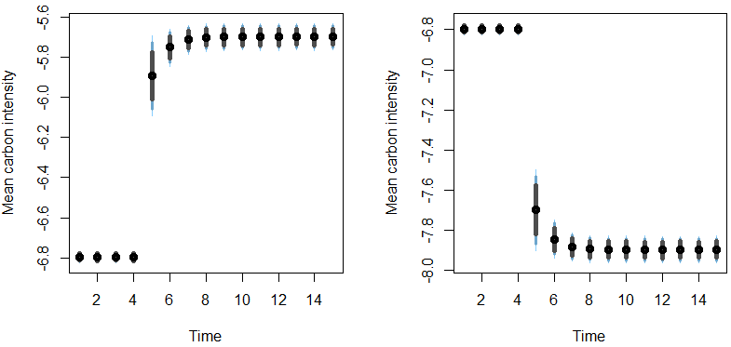
Fig. 1. Impulse response plots of energy intensity.
Notes: The plot on the left shows the 15-year response of carbon intensity to a 1% positive shock applied to energy intensity at the 5th year, while the plot on the right shows the 15-year response of carbon intensity to a 1% negative shock applied to energy intensity at the 5th year. The average predicted carbon intensity values are depicted as ⦁. Also, 75%, 90%, and 95% confidence levels are represented in a vertical line using the colors from gray to light blue, respectively.

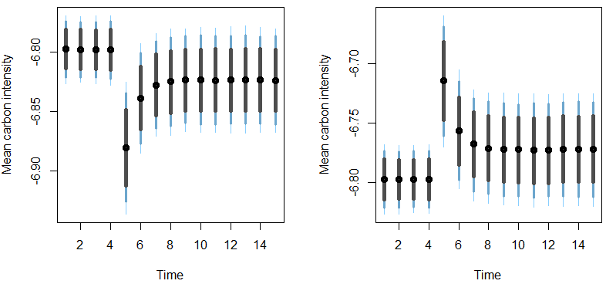
Fig. 2. Impulse response plots of renewable energy.
Notes: The plot on the left shows the 15-year response of carbon intensity to a 1% positive shock applied to renewable energy at the 5th year, while the plot on the right shows the 15-year response of carbon intensity to a 1% negative shock applied to renewable energy at the 5th year. The average predicted carbon intensity values are depicted as ⦁. Also, 75%, 90%, and 95% confidence levels are represented in a vertical line using the colors from gray to light blue, respectively.
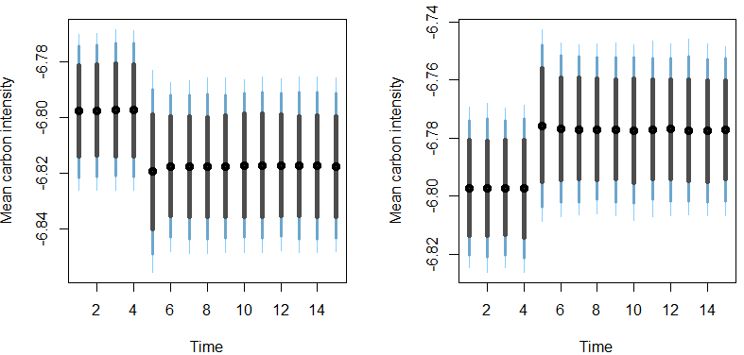
Fig. 3. Impulse response plots of natural resources.
Notes: The plot on the left shows the 15-year response of carbon intensity to a 1% positive shock applied to natural resources at the 5th year, while the plot on the right shows the 15-year response of carbon intensity to a 1% negative shock applied to natural resources at the 5th year. The average predicted carbon intensity values are depicted as ⦁. Also, 75%, 90%, and 95% confidence levels are represented in a vertical line using the colors from gray to light blue, respectively.

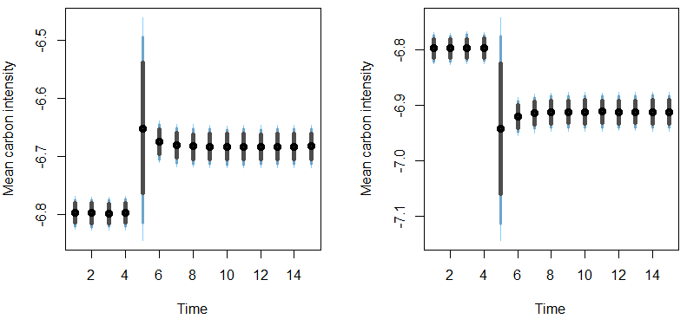
Fig. 4. Impulse response plots of economic growth.
Notes: The plot on the left shows the 15-year response of carbon intensity to a 1% positive shock applied to economic growth at the 5th year, while the plot on the right shows the 15-year response of carbon intensity to a 1% negative shock applied to economic growth at the 5th year. The average predicted carbon intensity values are depicted as ⦁. Also, 75%, 90%, and 95% confidence levels are represented in a vertical line using the colors from gray to light blue, respectively.

3.3.2. Diagnostic tests
The outputs of the diagnostic tests to determine whether the findings of DSARDL mentioned above are valid or not are presented in Table 7. Results disclose that the model used has no issues with serial correlation, heteroscedasticity, ARCH effect, omitted variable, and non-normality. Also, plots of cummulative sum (CUSUM) and CUSUM of squares tests in Fig. 5 reveal that the model is stable. The outputs of the diagnostic tests prove the validity of the obtained findings from the DSARDL method.

Table 7
Model diagnostic tests results
Diagnostic tests | χ² p-values
Breusch-Godfrey serial correlation LM test | 0.620
Breusch Pagan Godfrey | 0.759
ARCH | 0.323
Ramsey RESET | 0.360
Jarque-Bera | 0.601

Fig. 5. Plots obtained from the CUSUM and CUSUM of squares tests.
3.4. Kernel-based regularized least squares (KRLS) test
This section includes a robustness analysis to check the validity of the DSARDL findings. For robustness, we also analyze the impact of energy intensity, renewable energy, natural resources, and economic growth on carbon intensity in India by running the KRLS method established by Hainmueller and Hazlett (2014). This approach includes a machine learning algorithm with econometric properties. The KRLS method, in contrast to existing standard econometric methods, constructs pointwise derivatives and mean marginal effects, does hypothesis testing, and generates robust and reliable estimates. In a similar vein, the KRLS method outperforms existing machine learning algorithms with issues of misspecification bias over statistical judgments. In addition, the KRLS method provides flexible and interpretable parameters in regression and classification conundrums with undetermined functional forms. In other words, it determines the functional form of the data series under consideration and protects practitioners against misspecification bias. Furthermore, the KRLS approach is helpful for analysis incorporating learning about the data creation process, model-driven causal examination, forecast, and imputation of missing data (Hainmueller & Hazlett, 2014; Sarkodie et al., 2021).
The results of the KRLS test are reported in Table 8. We determine that the KRLS model’s predictive power (R²) is 0.989%, demonstrating that the factor variables (namely energy intensity, renewable energy, natural resources, and economic growth) explain 98.9% of the variance in the dependent variable, i.e., carbon intensity. The estimated average marginal effects imply that energy intensity and economic growth increase carbon intensity by 0.832% and 0.084%, whereas renewable energy and natural resources decrease carbon intensity by 0.055% and 0.008%, respectively.
Table 8
The KRLS results
 | Avg. | SE | T | P > t | P25 | P50 | P75
EINT | 0.832ª | 0.033 | 25.150 | 0.000 | 0.624 | 0.820 | 1.058
REC | -0.055ª | 0.013 | -4.225 | 0.000 | -0.115 | -0.041 | 0.013
NR | -0.008ª | 0.007 | -1.137 | 0.000 | -0.033 | -0.003 | 0.026
EG | 0.084ª | 0.007 | 12.353 | 0.000 | 0.058 | 0.095 | 0.128
Diagnostics
R² | 0.989 | Lambda | 0.061 | Sigma | 4 | Looloss | 0.185
Notes: This table represents pointwise derivatives obtained from KRLS. 1%, 5%, and 10% confidence levels are represented as ª, ^{b}, and ^{c}, respectively. Lambda is the value of regularization parameter, sigma specifies the bandwidth, and Looloss shows Leave-On-Out error. Also P25, P50, and P75 signify 1st quartile, median, and 3rd quartile, respectively.
Furthermore, we plot the pointwise marginal effects of energy intensity, renewable energy, natural resources, and economic growth on carbon intensity in Figs. 6 to 9. Figs. 6 and 9 illustrate that energy intensity and economic growth affect carbon intensity (environmental quality) positively (negatively) up to a certain point, after which the effect decreases slightly. After that, however, the positive (negative) effect on carbon intensity (environmental quality) continues.
On the other hand, Figs. 7 and 8 show that renewable energy and natural resources negatively (positively) affect carbon intensity (environmental quality) up to a certain point, after which the effect decreases slightly. And then, the negative (positive) effect on carbon intensity (environmental quality) increases again. The findings obtained from the DSARDL method are robust by all these findings. Finally, the findings of the study are summarized in Fig. 10.
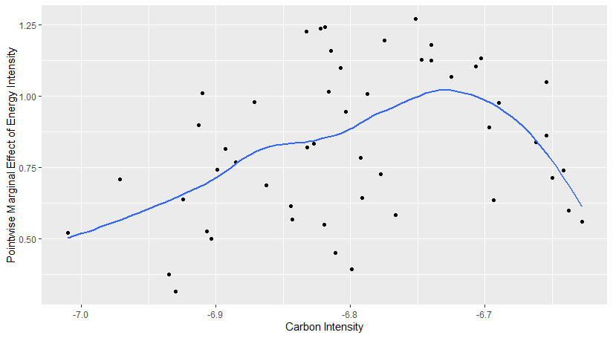
Fig. 6. Pointwise marginal effects of energy intensity on carbon intensity

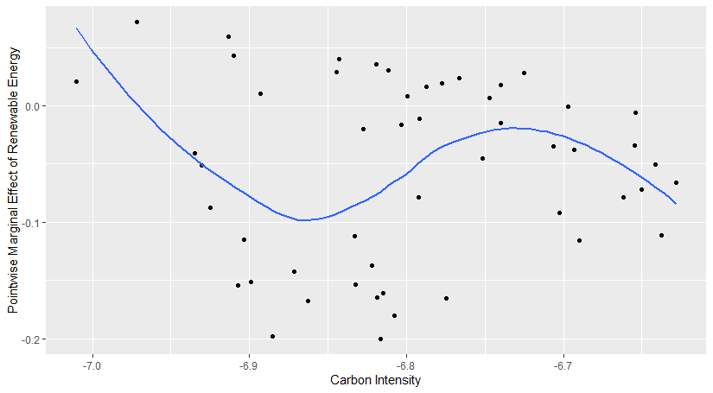
Fig. 7. Pointwise marginal effects of renewable energy on carbon intensity

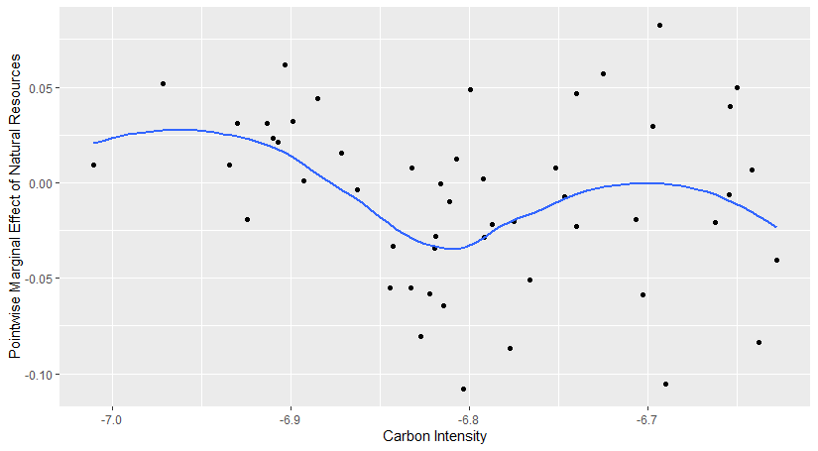
Fig. 8. Pointwise marginal effects of natural resources on carbon intensity

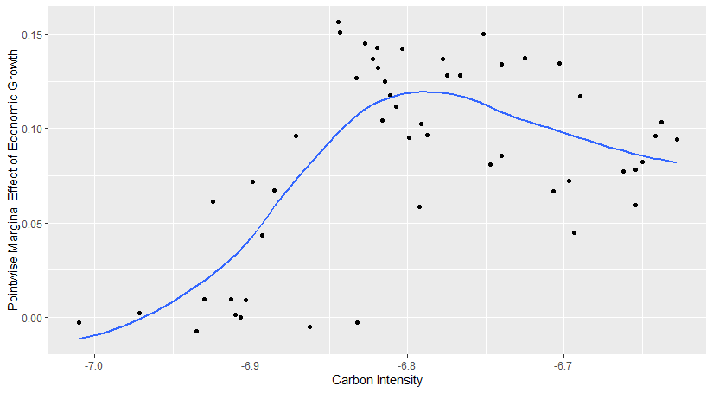
Fig. 9. Pointwise marginal effects of economic growth on carbon intensity

EINT
REC
NR
EG
Carbon Intensity
Fig. 10. Visualization of the results
4. Conclusion and policy recommendations
For most nations, a sustainable and pollution-free environment has been a priority. However, it should be emphasized that it is practically hard to arouse a shared interest due to the glaring inequalities in economic and social standards between nations. Several industrialized and developing nations intend to reduce their carbon intensity to realistic targets set by national policies, both independently and as participants in multilateral agreements (Majumdar & Kar, 2017). This investigated energy intensity, renewable energy, natural resources, economic growth, and carbon intensity nexus in India using data from 1970 to 2020. The DSARDL method, employed in this study, uses stochastic simulations to estimate, simulate, and provide the short and long-run coefficients with p-values for statistical inference of the model used, which typical approaches may neglect. According to the DSARDL, energy intensity and carbon intensity are positively correlated. Economic growth and carbon intensity are also observed to have a positive relationship over time. However, we find a negative relationship between natural resources and carbon intensity. Additionally, a negative association between renewable energy and carbon intensity is observed, but this correlation is not statistically significant over the long term. The KRLS approach was used for robustness since it beats current machine learning algorithms in terms of bias caused by misspecification over statistical judgments.
Although this study profers interesting interesting result, yet it suggests that salient environmental-related questions could further answered in the context of India if regional-level and cross industry examination is considered. Moreover, this study could further be explored by employing more macroeconomic and energy indicators alongside the greenhouse gases or ecological footprint components considering that India state is ecological deficit.
Overall, this study strengthens the idea that as the demand for energy increases and a country advances economically, it prompts a surge in carbon intensity. Therefore, it is pertinent for India to introduce policies to help abate the environmental impact of this demand as they prosper economically. For instance, investment in clean energy development could be advanced through provision of credit and energy subsidies as a way of depleting share of fossil fuels in total primary energy. Additionally, to further discourage carbon emission activities, environmental tax especially for energy-intensive industries could be increased while providing subsidies that encourages energy transition. In addition to the important implications of this study, India has to keep a close watch on how household energy use varies by income level in light of the country's significant population of people that lack access to clean cooking. Additionally, even though increasing natural resources rent reduces carbon intensity, the government should take urgent steps to ensure sustainable natural resources along with rising revenue. This is because increased natural resource extraction through agriculture, deforestation, and mining which are prominent economic activities in the country could continue to hurt it environment if not effectively checked.
References
Abbasi, K. R., Adedoyin, F. F., Abbas, J., & Hussain, K. (2021). The impact of energy depletion and renewable energy on CO₂ emissions in Thailand: Fresh evidence from the novel dynamic ARDL simulation. Renewable Energy, 180, 1439-1450. https://doi.org/10.1016/j.renene.2021.08.078
Adebayo, T. S., & Kalmaz, D. B. (2021). Determinants of CO₂ emissions: empirical evidence from Egypt. Environmental and Ecological Statistics, 28, 239-262.
Adebayo, T. S., Awosusi, A. A., & Adeshola, I. (2020). Determinants of CO2 Emissions in Emerging Markets: An Empirical Evidence from MINT Economies. International Journal of Renewable Energy Development, 9(3), 411–422. https://doi.org/10.14710/ijred.2020.31321
Agboola, P. O., Hossain, Md. E., Gyamfi, B. A., & Bekun, F. V. (2022). Environmental consequences of foreign direct investment influx and conventional energy consumption: evidence from dynamic ARDL simulation for Turkey. Environmental Science and Pollution Research, 29, 53584-53597.
Ahad, M., & Imran, Z. A. (2022). The role of shadow economy to determine CO₂ emission in Pakistan: evidence from novel dynamic simulated ARDL model and wavelet coherence analysis. Environment, Development and Sustainability. https://doi.org/10.1007/s10668-022-02164-2.
Ahmad, M., & Wu, Y. (2022). Natural resources, technological progress, and ecological efficiency: Does financial deepening matter for G-20 economies? Resources Policy, 77, 102770. https://doi.org/10.1016/j.resourpol.2022.102770.
Akadiri, S. S., & Adebayo, T. S. (2022). Asymmetric nexus among financial globalization, non-renewable energy, renewable energy use, economic growth, and carbon emissions: impact on environmental sustainability targets in India. Environmental Science and Pollution Research, 29(11), 16311-16323.
Akadırı, S. S., Alola, A. A., & Usman, O. (2021). Energy mix outlook and the EKC hypothesis in BRICS countries: a perspective of economic freedom vs. economic growth. Environmental Science and Pollution Research, 28, 8922-8926.
Ali, H. S., Abdul-Rahim, AS., & Ribadu, M. B. (2017). Urbanization and carbon dioxide emissions in Singapore: evidence from the ARDL approach. Environmental Science and Pollution Research, 24, 1967-1974.
Alola, A. A., Bekun, F. V., & Sarkodie, S. A. (2019). Dynamic impact of trade policy, economic growth, fertility rate, renewable and non-renewable energy consumption on ecological footprint in Europe. Science of the Total Environment, 685, 702–709.
Alola, A. A., Doganalp, N., & Obekpa, H. O. (2022). The influence of renewable energy and economic freedom aspects on ecological sustainability in the G7 countries. Sustainable Development, sd.2414. https://doi.org/10.1002/sd.2414
Bekun, F. V., Alola, A. A., & Sarkodie, S. A. (2019). Toward a sustainable environment: Nexus between CO2 emissions, resource rent, renewable and nonrenewable energy in 16-EU countries. Science of The Total Environment, 657, 1023–1029. https://doi.org/10.1016/j.scitotenv.2018.12.104
Bhowmik, R., Syed, Q. R., Apergis, N., Alola, A. A., & Gai, Z. (2022). Applying a dynamic ARDL approach to the Environmental Phillips Curve (EPC) hypothesis amid monetary, fiscal, and trade policy uncertainty in the USA. Environmental Science and Pollution Research, 29, 14914-14928.
Damerau, K., Davis, K. F., Godde, C., Herrero, M., Springmann, M., Bhupathiraju, S. N., ... & Willett, W. (2020). India has natural resource capacity to achieve nutrition security, reduce health risks and improve environmental sustainability. Nature Food, 1(10), 631-639.
Danish, Baloch, M. A., & Suad, S. (2018). Modeling the impact of transport energy consumption on CO₂ emission in Pakistan: Evidence from ARDL approach. Environmental Science and Pollution Research, 25, 9461-9473.
Danish, Baloch, M. A., Mahmood, N., & Zhang, J. W. (2019). Effect of natural resources, renewable energy and economic development on CO2 emissions in BRICS countries. Science of The Total Environment, 678, 632–638. https://doi.org/10.1016/j.scitotenv.2019.05.028
Dickey, D. A., & Fuller, W. A. (1979). Distribution of the estimators for autoregressive time series with a unit root. Journal of the American Statistical Association, 74(366), 427-431.
Douglas, S., & Nishioka, S. (2012). International differences in emission intensity and emission content of global trade. Journal of Development Economics, 99(2), 415-427.
Eurostat (2016). Energy intensity of the economy. Available from: ec.eurostat/web/products-datasets/-tsdec360.
Goldemberg, J. (2020). The evolution of the energy and carbon intensities of developing countries. Energy Policy, 137, 111060. https://doi.org/10.1016/j.enpol.2019.111060
Hainmueller, J., & Hazlett, C. (2014). Kernel regularized least squares: reducing misspecification bias with a flexible and interpretable machine learning approach. Political Analysis, 22(2), 143-168.
Hanif, I., Faraz Raza, S. M., Gago-de-Santos, P., & Abbas, Q. (2019). Fossil fuels, foreign direct investment, and economic growth have triggered CO2 emissions in emerging Asian economies: Some empirical evidence. Energy, 171, 493–501. https://doi.org/10.1016/j.energy.2019.01.011
Hatmanu, M., Cautisanu, C., & Iacobuta, A. O. (2022). On the relationships between CO₂ emissions and their determinants in Romania and Bulgaria. An ARDL approach. Applied Economics, 54(22), 2582-2595.
Holdren, J. P., & Ehrlich, P. R. (1974). Human Population and the Global Environment: Population growth, rising per capita material consumption, and disruptive technologies have made civilization a global ecological force. American scientist, 62(3), 282-292.
Hongdou, L., Shiping, L., & Hao, L. (2018). Existing agricultural ecosystem in China leads to environmental pollution: An econometric approach. Environmental Science and Pollution Research, 25(24), 24488–24499. https://doi.org/10.1007/s11356-018-2461-9
Huang, S.-Z., Chau, K.Y., Chien, F., & Shen, H. (2020). The impact of startups’ dual learning on their green innovation capability: the effects of business executives’ environmental awareness and environmental regulations. Sustainability. 12(16):1–17.
Huang, S.-Z., Sadiq, M., & Chien, F. (2021). The impact of natural resource rent, financial development, and urbanization on carbon emission. Environmental Science and Pollution Research. https://doi.org/10.1007/s11356-021-16818-7
IEA (2022). India’s clean energy transition is rapidly underway, benefiting the entire world. https://www.iea.org/commentaries/india-s-clean-energy-transition-is-rapidly-underway-benefiting-the-entire-world. (Accessed 01 November 2022).
IEA. (2021). India Energy Outlook 2021, IEA, Paris https://www.iea.org/reports/india-energy-outlook-2021. (Accessed 01 November 2022).
Islam, Md. S., Hossain, Md. E., Khan, Md. A., Rana, Md. J., Ema, N. S., & Bekun, F. V. (2022). Heading towards sustainable environment: exploring the dynamic linkage among selected macroeconomic variables and ecological footprint using a novel dynamic ARDL simulations approach. Environmental Science and Pollution Research, 29, 22260-22279.
Iwata, H., Okada, K., & Samreth, S. (2012). Empirical study on the determinants of CO₂ emissions: evidence from OECD countries. Applied Economics, 44(27), 3513-3519.
Itoo, H. H., & Ali, N. (2023). Analyzing the causal nexus between CO2 emissions and its determinants in India: Evidences from ARDL and EKC approach. Management of Environmental Quality: An International Journal, 34(1), 192-213.
Ji, X., Umar, M., Ali, S., Ali, W., Tang, K., & Khan, Z. (2021). Does fiscal decentralization and eco‐innovation promote sustainable environment? A case study of selected fiscally decentralized countries. Sustainable Development, 29(1), 79–88. https://doi.org/10.1002/sd.2132
Jordan, S., & Philips, A. Q. (2018). Cointegration testing and dynamic simulations of autoregressive distributed lag models. The Stata Journal, 18(4), 902-923.
Kalmaz, D. B., & Kirikkaleli, D. (2019). Modeling CO2 emissions in an emerging market: Empirical finding from ARDL-based bounds and wavelet coherence approaches. Environmental Science and Pollution Research, 26(5), 5210–5220. https://doi.org/10.1007/s11356-018-3920-z
Khan, F. U., Rafique, A., Ullah, E., & Khan, F. (2022). Revisiting the relationship between remittances and CO₂ emissions by applying a novel dynamic simulated ARDL: empirical evidence from G-20 economies. Environmental Science and Pollution Research. https://doi.org/10.1007/s11356-022-20768-z.
Khan, I., Hou, F., & Le, H. P. (2021). The impact of natural resources, energy consumption, and population growth on environmental quality: Fresh evidence from the United States of America. Science of the Total Environment, 754, 142222. https://doi.org/10.1016/j.scitotenv.2020.142222
Khan, Z., Ali, S., Umar, M., Kirikkaleli, D., & Jiao, Z. (2020). Consumption-based carbon emissions and International trade in G7 countries: The role of Environmental innovation and Renewable energy. Science of The Total Environment, 730, 138945. https://doi.org/10.1016/j.scitotenv.2020.138945
Kripfganz, S., & Schneider, D. C. (2020). Response surface regressions for critical value bounds and approximate p-values in equilibrium correction models 1. Oxford Bulletin of Economics and Statistics, 82, 1456-1481.
Majumdar, D., & Kar, S. (2017). Does technology diffusion help to reduce emission intensity? Evidence from organized manufacturing and agriculture in India. Resource and Energy Economics, 48, 30–41. https://doi.org/10.1016/j.reseneeco.2017.01.004
Menegaki, A. N., & Tsani, S. (2018). Critical Issues to Be Answered in the Energy-Growth Nexus (EGN) Research Field. In The Economics and Econometrics of the Energy-Growth Nexus (pp. 141–184). Elsevier. https://doi.org/10.1016/B978-0-12-812746-9.00005-5
Musah, M., Owusu-Akomeah, M., Kumah, E. A., Mensah, I. A., Nyeadi, J. D., Murshed, M., & Alfred, M. (2022). Green investments, financial development, and environmental quality in Ghana: evidence from the novel dynamic ARDL simulations approach. Environmental Science and Pollution Research, 29, 31972-32001.
Namahoro, J. P., Wu, Q., Zhou, N., & Xue, S. (2021). Impact of energy intensity, renewable energy, and economic growth on CO₂ emissions: Evidence from Africa across regions and income levels. Renewable and Sustainable Energy Reviews, 147, 111233. https://doi.org/10.1016/j.rser.2021.111233
Ncube, B., & Koloba, H. A. (2020). Branded Mobile App Usage Intentions Among Generation Y Students: A Comparison of Gender and Education Level. International Journal of EBusiness and EGovernment Studies, 12(2), 91–106. https://doi.org/10.34111/ijebeg.202012201
Neves, S. A., Marques, A. C., & Patrício, M. (2020). Determinants of CO₂ emissions in European Union countries: Does environmental regulation reduce environmental pollution?. Economic Analysis and Policy, 68, 114-125.
OECD. (2011). Energy, OECD Growth Studies Energy; OECD: Paris, France.
Olasehinde-Williams, G., & Oshodi, A. F. (2021). Global value chains and export growth in South Africa: evidence from dynamic ARDL simulations. Transnational Corporations Review. https://doi.org/10.1080/19186444.2021.1959833.
Olasehinde-Williams, G., & Özkan, O. (2022). A consideration of the environmental externality of Turkey’s integration into global value chains: evidence from dynamic ARDL simulation model. Environmental Science and Pollution Research. https://doi.org/10.1007/s11356-022-24272-2.
OWD (2022a). Our World in Data. https://ourworldindata.org/grapher/per-capita-renewables (accessed 04 October 2022).
OWD (2022b). Our World in Data. https://ourworldindata.org/grapher/per-capita-energy-use (accessed 04 October 2022).
OWD (2022c). Our World in Data. https://ourworldindata.org/grapher/co-emissions-per-capita (accessed 04 October 2022).
Pata, U. K., Erdogan, S., & Ozkan, O. (2023). Is reducing fossil fuel intensity important for environmental management and ensuring ecological efficiency in China?. Journal of Environmental Management, 329, 117080. https://doi.org/10.1016/j.jenvman.2022.117080.
Pesaran, M. H., Shin, Y., & Smith, R. J. (2001). Bounds testing approaches to the analysis of level relationships. Journal of Applied Econometrics, 16(3), 289-326.
Phillips, P. C. B, & Perron, P. (1988). Testing for a unit root in time series regression. Biometrika, 75(2), 335-346.
Rahman, H. U., Ghazali, A., Bhatti, G. A., & Khan, S. U. (2020). Role of Economic Growth, Financial Development, Trade, Energy and FDI in Environmental Kuznets Curve for Lithuania: Evidence from ARDL Bounds Testing Approach. Inzinerine Ekonomika-Engineering Economics, 31(1), 39-49.
Rahman, M. M., Sultana, N., & Velayutham, E. (2022). Renewable energy, energy intensity and carbon reduction: Experience of large emerging economies. Renewable Energy, 184, 252–265. https://doi.org/10.1016/j.renene.2021.11.068
Sarkodie, S. A., Ahmed, M. Y., & Owusu, P. A. (2021). Ambient air pollution and meteorological factors escalate electricity consumption. Science of The Total Environment, 795, 148841. https://doi.org/10.1016/j.scitotenv.2021.148841
Shah, M. I., Usman, M., Obekpa, H. O., & Abbas, S. (2022). Nexus between environmental vulnerability and agricultural productivity in BRICS: What are the roles of renewable energy, environmental policy stringency, and technology? Environmental Science and Pollution Research. https://doi.org/10.1007/s11356-022-23179-2
Solarin, S. A. (2014). Tourist arrivals and macroeconomic determinants of CO₂ emissions in Malaysia. Anatolia, 25(2), 228-241.
Su, B., & Ang, B.W. (2013). Input–output analysis of CO2 emissions embodied in trade: Competitive versus non-competitive imports. Energy Policy, 56, 83-87.
The Washington Post. (2020). https://www.washingtonpost.com/climate-solutions/2020/06/12/india-emissions-climate/ (accessed 13 October 2022).
Tufail, M., Song, L., Adebayo, T. S., Kirikkaleli, D., & Khan, S. (2021). Do fiscal decentralization and natural resources rent curb carbon emissions? Evidence from developed countries. Environmental Science and Pollution Research, 28(35), 49179–49190. https://doi.org/10.1007/s11356-021-13865-y
Udemba, E. N. (2022). Cushioning environmental damage with institutions and FDI: study of sustainable development goals (SDGs). Environment, Development and Sustainability, 1-21.
Umar, M., Ji, X., Kirikkaleli, D., & Xu, Q. (2020). COP21 Roadmap: Do innovation, financial development, and transportation infrastructure matter for environmental sustainability in China? Journal of Environmental Management, 271, 111026. https://doi.org/10.1016/j.jenvman.2020.111026
United Nations (2021). Facts and Figures. https://www.un.org/en/actnow/facts-and-figures. (Accessed 13 October, 2022).
Wang, Q., Li, L., & Li, R. (2023a). Uncovering the impact of income inequality and population aging on carbon emission efficiency: An empirical analysis of 139 countries. Science of The Total Environment, 857, 159508.
Wang, Q., Li, S., & Pisarenko, Z. (2020). Modeling carbon emission trajectory of China, US and India. Journal of Cleaner Production, 258, 120723. https://doi.org/10.1016/j.jclepro.2020.120723
Wang, Q., Zhang, F., & Li, R. (2023b). Revisiting the environmental kuznets curve hypothesis in 208 counties: The roles of trade openness, human capital, renewable energy and natural resource rent. Environmental Research, 216, 114637.
WDI (2022a). World development indicators of the World Bank. https://data.worldbank.org/indicator/NY.GDP.PCAP.KD?locations=IN (accessed 05 October 2022).
WDI (2022b). World development indicators of the World Bank. https://data.worldbank.org/indicator/NY.GDP.TOTL.RT.ZS?locations=IN (accessed 05 October 2022).
WEF (2012). Energy for economic growth. https://www.weforum.org
York, R., Rosa, E. A., & Dietz, T. (2003). STIRPAT, IPAT and ImPACT: analytic tools for unpacking the driving forces of environmental impacts. Ecological economics, 46(3), 351-365.
Zhang, L., Mu, R., Zhan, Y., Yu, J., Liu, L., Yu, Y., & Zhang, J. (2022). Digital economy, energy efficiency, and carbon emissions: Evidence from provincial panel data in China. Science of The Total Environment, 852, 158403. https://doi.org/10.1016/j.scitotenv.2022.158403
Zhu, B., Su, B., & Li, Y. (2018). Input-output and structural decomposition analysis of India’s carbon emissions and intensity, 2007/08 – 2013/14. Applied Energy, 230, 1545–1556. https://doi.org/10.1016/j.apenergy.2018.09.026
Zoaka, J. D., Ekwueme, D. C., Güngör, H., & Alola, A. A. (2022). Will financial development and clean energy utilization rejuvenate the environment in BRICS economies?. Business Strategy and the Environment, 31(5), 2156-2170.

1 The KS critical values provide more reliable and robust outcomes where the sample size is small. (Olasehinde-Williams & Özkan, 2022). Therefore, we prefer the KS critical values because of the study's relatively small sample size.

